1 df

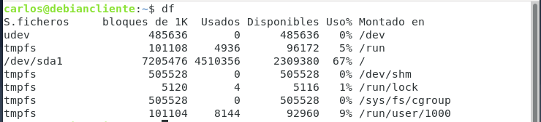

2 top

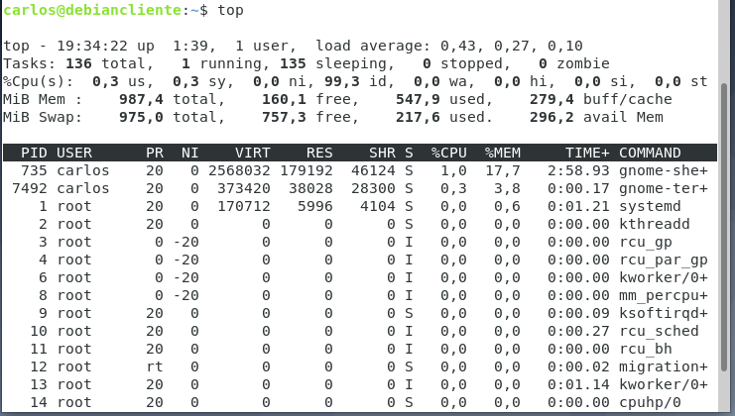

3 apt-get upgrade

